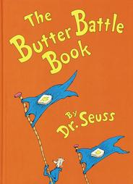
The Butter Battle Book
By Dr. Seuss

The Butter Battle Book was written by Dr. Seuss in 1984, during the Cold War. The Cold War began in 1945 and lasted until 1989. The Cold War was “cold” primarily because of the threat of nuclear weapons and the absence of actual fighting. The US launched its first nuclear weapon, the atomic bomb, in 1945 and The Soviet followed with its first nuclear weapon in 1949. This started an “arms race” between the United States and the Soviet Union. At the height of the Cold War, the combined weapons of the two “superpowers” were enough to destroy the world six times over.

Name three similarities from the Butter Battle to events/aspects of the Cold War:

Butter Battle Book | Cold War
1.  2.  3. | 1.  2.  3.

Why do the Yooks and Zooks keep getting bigger and stronger weapons?

What do you think caused the conflict to get worse?

Can anyone win this battle? How? Or Why not?

Identify a theme of the book. In other words, what is the moral (lesson) of the story?

What do you think Dr. Seuss is saying about the Cold War?

BONUS!
Are you a Yook or a Zook? Defend your reasons.

